Virtual Public Information Center
October 21, 2024 through October 31, 2024
Route 46 Bridges over Route 17
Borough of Hasbrouck Heights, Bergen County

The New Jersey Department of Transportation (NJDOT), committed to developing transportation improvements that best balance the transportation needs, the environment, community concerns and cost, will hold a Virtual Public Information Center (PIC) to provide local residents and businesses with information on the Route 46 Bridges over Route 17 project. You are encouraged to actively participate by providing comments by mail or email.

THE MEETING
Please visit the following website any time between October 21, 2024 and October 31, 2024 to learn more about the project and to leave comments:

https://www.dewberry.com/pages/route-46-bridges-over-route-17/

You will have an opportunity to review a presentation, exhibits of the draft plans, submit questions, and leave feedback. Property owners with rental units are advised that tenants are also invited and encouraged to participate.

BACKGROUND

The following Route 46 Bridges over Route 17 have been identified as in need of repairs:

Route 46 mainline Bridge over Route 17 southbound
- Route 46 mainline Bridge over Route 17 northbound

Route 46 eastbound On-Ramp Bridge (Ramp A) over Route 17 northbound

The purpose of this project is to rehabilitate or replace these three existing bridges and address safety and traffic operational improvements within the project limits.

THE PROPOSED PROJECT
The proposed project will replace the two Route 46 mainline Bridges over Route 17 northbound and southbound and widen the Route 46 roadway section to include full shoulders. It will also include a sidewalk along Route 46 eastbound where pedestrian traffic is predominant. To accommodate an outside shoulder and sidewalk on Route 46 eastbound over Route 17 northbound, the Ramp A Bridge over Route 17 northbound will be realigned to the south and the entire superstructure will be replaced. Acceleration and deceleration lanes along Route 46 will also be provided where feasible. Route 17 northbound will also be widened to accommodate wider shoulders, and Route 17 southbound will be widened to include two through lanes, a dedicated lane from Terrace Ave Ramp, full shoulders and a Collector-Distributor (C-D) Road to mitigate weaving southbound traffic with traffic from Route 46 westbound ramp and traffic to the Route 46 eastbound Ramp. This C-D Road will be separated from Route 17 southbound mainline traffic using a concrete median island. The Route 46 Bridge over Route 17 southbound will be constructed to accommodate a future third through lane along Route 17 southbound. The existing interchange ramp movements will be maintained in the proposed condition.

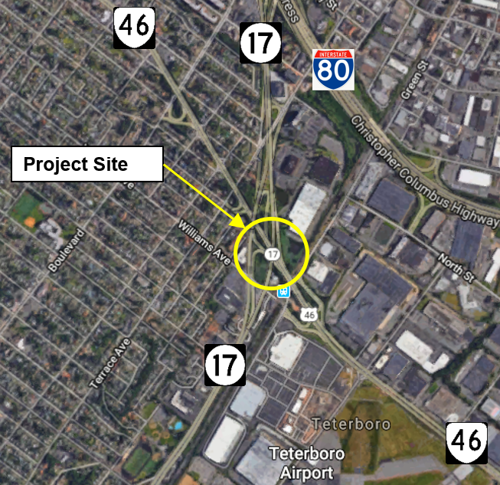

Staged construction with traffic shifts will be performed to maintain Route 46 and Route 17 lanes during peak hours. Ramp closures with detours are anticipated.

PROJECT SCHEDULE
Complete Concept Development: Jan-Mar 2025
Complete Preliminary Engineering: TBD
Complete Final Design: TBD
Start Construction: TBD
Complete Construction: TBD

For Special Accommodations, please contact:
862-955-1306

For further information contact:

Shivon Harris, Regional Area Coordinator
New Jersey Department of Transportation
Office of Government & Community Relations
1035 Parkway Avenue, PO Box 600
Trenton, NJ 08625 - 0600
Phone: 609-963-1218
Email: shivona.harris@dot.nj.gov

