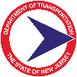 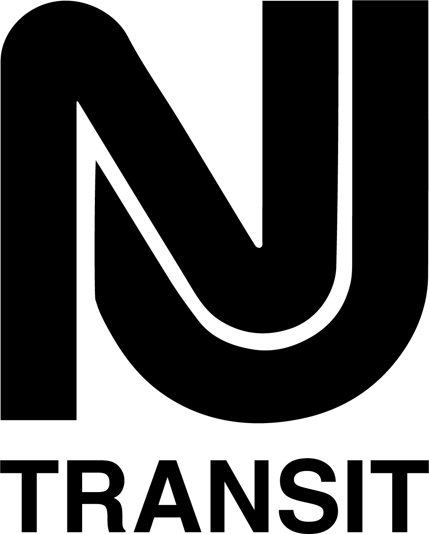

**Transit Village Application Requirements**

**2025**

**Municipal Contact Information:**

**Municipality:**

**County:**

**Person Responsible for Preparing this Form:**

**Phone:**

**Email:**

**Primary Contact Person:**

**Phone:**

**Email:**

**Municipal Planner:**

**Phone:**

**Email:**

**PART A - Transit Village Criteria**

1. **ATTEND A PRE-APPLICATION MEETING**

**a.** Before applying for Transit Village designation, a municipality must have had a pre-application meeting with the NJDOT Transit Village Coordinator no more than six months prior to submitting this application. Provide the date of the pre-application meeting. No deadline is set if an applicant is working in good faith toward completing the application. Otherwise, the pre-application meeting must be repeated.

**Answer:** Click or tap here to enter text.

1. **IDENTIFY EXISTING TRANSIT THAT SERVES THE MUNICIPALITY AND THE PROPOSED TRANSIT VILLAGE DISTRICT**

**a.** List and describe modes and routes of transit that currently serve the proposed Transit Village District. What type of facility is the focal point? (Bus terminal, train station, bus stop, ferry terminal). What steps has the municipality taken to integrate these modes in order to help transit riders easily transfer from one to another? Please provide the ridership data for current year, available at [New Jersey Land Use + Transit Data Application (njlutrans.org)](https://njlutrans.org/)

**Answer:** Click or tap here to enter text.

1. **DEMONSTRATE MUNICIPAL WILLINGNESS TO GROW AROUND THE TRANSIT FACILITY IN A TRANSIT-SUPPORTIVE MANNER**

**a.** To be considered for designation, the governing body must demonstrate its commitment to growth in jobs, housing, and population within the proposed Transit Village District. Provide a copy of the adopted Transit Village Resolution (See Appendix A for sample resolution).

**Answer:** Click or tap here to enter text.

**b.** Describe and document the visioning process, including stakeholder engagement, specifically organized for the Transit Village District. Provide proof of public notice, minutes and public comments and feedback from each public workshop conducted as

part of the visioning process that corresponds to a current petition. Explain how the public was engaged in the process and what tools were used to facilitate the meeting.

Does the community as a whole support and understand development decisions? If meeting notes are not provided, or public meetings are not conducted, we recommend additional engagement activities to be conducted to ensure the relevant application criteria are satisfied. Such activities will help to ensure public buy-in of the municipality’s goal to become a Transit Village. List the interested parties/stakeholders of the visioning process.

**Answer:** Click or tap here to enter text.

**c.** Identify and provide sections of the most recent adopted master plan that articulates the municipality’s plan for transit-supportive growth around the transit facility.

**Answer:** Click or tap here to enter text.

**d.** Provide a map indicating the proposed limits of the transit village district (within the ½ mile radius of the transit facility)[1], and showing the transit facility. Describe the rationale for the district limits.

**Answer:** Click or tap here to enter text.

**e.** Provide a current zoning map (with ½ mile radius) that clearly identifies all the current zones in the proposed Transit Village District along with the applicable zoning codes (direct link or excerpts of the zoning ordinance) and land development ordinances. The ordinance content should be transit supportive, consistent with Transit Village criteria and guidance. Adopted transit-supportive zoning should be by-right zoning, not overlay zoning. In addition, zoning in the transit village district should strictly prohibit new auto-dependent uses such as drive-in/through establishments in that district. Existing establishments would be allowed to remain. In narrative form, please clarify how land use regulations and provisions support the municipality’s vision for the Transit Village District and further support the use of transit.  Please highlight or point to the sections of the standards and regulations that address the criteria.

**Answer:** Click or tap here to enter text.

1. **ADOPT A TOD REDEVELOPMENT PLAN AND/OR TOD ZONING ORDINANCE WHICH INCLUDES A RESIDENTIAL COMPONENT**

**a.** List and describe all adopted TOD redevelopment plans and/or TOD zoning ordinances in the proposed Transit Village District that call for compact, mixed-use, pedestrian-friendly, transit-supportive development, with a residential component at a scale and density appropriate for the area. Provide copies of, or link to, the adopted documents.

**Answer:** Click or tap here to enter text.

**b.** Provide a map clearly indicating the location and limits of any adopted TOD redevelopment plans and/or TOD zoning ordinances.

**Answer:** Click or tap here to enter text.

**c.** Provide copies of, or links to, the transit-supportive site design guidelines that have been enacted for the proposed Transit Village District.

**Answer:** Click or tap here to enter text.

**d**. Provide copies of, or links to, the transit-supportive architectural design guidelines that have been enacted for the proposed Transit Village District.

**Answer:** Click or tap here to enter text.

**e**. List and describe the parking improvements enacted for the proposed Transit Village District, such as a parking management system and/or reduced parking minimums or new parking maximum requirements. Provide documentation.

**Answer:** Click or tap here to enter text.

1. **IDENTIFY INDIVIDUAL SITES WHERE TOD PROJECTS HAVE BEEN APPROVED IN RECENT YEARS OR ARE CURRENTLY IN THE DEVELOPMENT APPLICATION PROCESS**

**a.** List each individual TOD project that was approved or is envisioned for the proposed Transit Village District. Describe each site and project (such as block, lot, address, acreage, current use, ownership, existing zoning, and proposed development) Provide a map that clearly identifies project locations within the ½ mile radius.

**Answer:** Click or tap here to enter text.

**b.** From the list of potential projects [from (a) above], identify which have already been submitted to the planning/zoning board for approvalsand**,** for all other sites**,** summarize the proactive steps taken by municipal representatives to advance projects.

**Answer:** Click or tap here to enter text.

**c.** List and describe the existing and proposed affordable housing efforts in the proposed Transit Village District. Provide a map that clearly identifies the locations. Describe the municipality’s history in meeting affordable housing obligations. In addition, the following statement must be added to the land development regulations for the proposed Transit Village District. Provide documentation.

52:27D-329.9 Developments, certain, in certain regional planning entities. b. *Subject to the provisions of subsection d. of this section, a developer of a project consisting of newly-constructed residential units being financed in whole or in part with State funds, including, but not limited to, transit villages designated by the Department of Transportation and units constructed on State-owned property, shall be required to reserve at least 20 percent of the residential units constructed for occupancy by low or moderate income households, as those terms are defined in section 4 of P.L.1985, c.222 (C.52:27D-304), with affordability controls as required under the rules of the agency.*

**Answer:** Click or tap here to enter text.

1. **IDENTIFY BICYCLE AND PEDESTRIAN IMPROVEMENTS WITHIN** **½ MILES OF THE TRANSIT FACILITY**

**a.** What formal commitment has the municipality made to improve the general bicycle and pedestrian friendliness of the proposed Transit Village District? Identify the adopted municipal documents (such as municipal policies, redevelopment objectives, bike-pedestrian master plan, complete streets policy, ordinance, and/or plan). Provide documentation for review.

**Answer:** Click or tap here to enter text.

**b.** What bicycle and pedestrian infrastructure projects has the municipality recently *implemented* in the proposed Transit Village District? Provide a map showing these improvements.

**Answer:** Click or tap here to enter text.

**c.** What bicycle and pedestrian infrastructure projects has the municipality *planned* for the proposed Transit Village District? Provide plans, funding sources, and timelines for completion.

**Answer:** Click or tap here to enter text.

**d.** What type of amenities are currently available for bicycles, bicyclists, and pedestrians at or near the transit facility? What physical barriers currently exist that make walking or bicycling to the transit facility from other neighborhoods difficult? What steps will the municipality take to increase the number of households that could walk or bike to the transit facility?

**Answer:** Click or tap here to enter text.

1. **IDENTIFY PLACEMAKING PROJECTS WITHIN½ MILES OF THE TRANSIT FACILITY**

***Note: A municipality must satisfy (a) and (b) below, and at least two from (c) through (f) below.***

**a.** List and describe existing and/or planned public amenities (community assets) at the transit facility that were initiated by the municipality, and their connection to transit. Examples are parks or plazas with seating, parklets, civic buildings, community center, library, public art, mural at the transit facility that were initiated by the municipality. Examples include park or plaza with seating, civic building, sculpture or statue, ornamental clock, fountain, memorial, information kiosk, and wayfinding signage. Provide photos. If an amenity is planned for the future, the municipality must provide plans, funding information, implementation details and timeline for completion.

**Answer:** Click or tap here to enter text.

**b.** Describe the management organization (such as chamber of commerce, Main Street organization, improvement district) or other form of organized stewardship that exists in the municipality. Does the organization manage all or part of the proposed Transit Village District? Provide a map showing the location/boundaries of the management district in relation to the boundaries of the proposed Transit Village District. If the management organization is only in the planning stages, provide a location map, budget, work plan and timeline for implementation.

List and describe all organized efforts for prescribed or directed care, maintenance or beautification of the transit facility and the surrounding neighborhood. Describe the procedures the municipality has implemented to handle maintenance such as garbage pick-up, litter and graffiti removal, general cleaning, and repairs, around the transit facility.

Describe public safety initiatives established or planned for the district, as well as partnerships, proactive problem-solving techniques, and/or community engagement activities that address crime, safety, equity, and community concerns.

**Answer:** Click or tap here to enter text.

***Note: Meet at least two from (c) through (f) below.***

**c.** List and describe at least two regularly scheduled community events (such as a farmer’s market, street fair, memorial event, or parade) that are initiated by the municipality and take place within sight of the transit facility. Provide documentation of the events and a location map showing where the events take place in relation to the transit facility.

**Answer:** Click or tap here to enter text.

**d.** List and describe what steps the municipality has taken to maintain and enhance the historic character of the proposed Transit Village District as development and/or redevelopment takes place. Provide documentation of any adopted historic design guidelines, a historic district, or an architectural review board.

**Answer:** Click or tap here to enter text.

**e.** List and describe existing or planned arts and cultural facilities within the proposed Transit Village District (such as performing arts centers, theaters, art galleries, museums, public art, programmable open space, cultural arts districts, and arenas). Provide location map showing where facilities are situated in relation to the transit facility. For anything currently in the planning stages, provide location map, description, budget, funding source, and timeline for completion.

List and describe any ongoing programmed arts, arts education, community arts activities or cultural events (such as concerts, poetry readings, dance classes) that take place in the proposed Transit Village District. Provide documentation.

**Answer:** Click or tap here to enter text.

**f.** List and describe all restaurants, shops, offices, and other establishments within sight of the transit facility that remain open beyond 5:00 PM and provide “eyes on the street[2].” Provide photos and location map showing where businesses are situated in relation to the transit facility. Include business hours.

**Answer:** Click or tap here to enter text.

**PART B - Transit Village Statement**

Explain how, when, and why the municipality became interested in becoming a designated Transit Village. Explain when the idea was first discussed publicly by the mayor and/or governing body, what the catalyst was for exploring this new direction, and how the designation could help the municipality.

Identify the community leaders who were responsible for championing the transit village concept. In addition, identify the person who would work to implement the vision after the designation is approved.

**Answer:** Click or tap here to enter text.

**PART C - State Assistance Needed**

Along with NJDOT and NJ TRANSIT, the Transit Village Task Force is made up of the Council on the Arts, the Department of Community Affairs, the Department of Environmental Protection, the Economic Development Authority, the Housing and Mortgage Finance Agency, the Office of Planning Advocacy, and the Redevelopment Authority. In the space below, indicate which agencies the municipality would like to meet with regarding the municipality’s proposed Transit Village District. Be sure to specify the type of assistance desired.

**Answer:** Click or tap here to enter text.

**PART D - Transit Village Progress Report**

Municipalities with designated Transit Villages will be required to submit annual updates as requested by the Task Force. The report should indicate how they progressed on various elements, such as ridership data, development and redevelopment projects, bicycle and pedestrian improvements, and placemaking projects.

**Answer:** Click or tap here to enter text.

**APPENDIX A**

**Transit Village Initiative Resolution Model**

**WHEREAS**, the NJ Department of Transportation (NJDOT) has created a Smart Growth community revitalization and redevelopment program known as the Transit Village Initiative; and

**WHEREAS,** the Transit Village Initiative supports Smart Growth, revitalization, and redevelopment within walking distance of transit for the purpose of increasing transit ridership, reducing automobile congestion and improving air quality in the State of New Jersey; and

**WHEREAS**, the NJDOT along with NJ TRANSIT, the Department of Community Affairs, the Department of Environmental Protection, the Redevelopment Authority, the Council on the Arts, Main Street New Jersey, the Economic Development Authority, the Office for Planning Advocacy and the Housing and Mortgage Finance Agency are partners in the Transit Village Initiative and make up the Transit Village Task Force; and

**WHEREAS**, the NJDOT may designate a Transit Village after the municipality has achieved the Transit Village Criteria established by the Transit Village Task Force; and

**WHEREAS,** once a municipality has been deemed a Transit Village, the Transit Village Task Force will provide that municipality with (1) a contact person in each of the state agencies that make up the Transit Village Task Force; (2) technical assistance from each agency; (3) up-to-date information on grants, loans, programs or other opportunities; (4) priority funding where feasible; and (5) access to special information meetings, educational programs and research information; and

**WHEREAS**, the governing body of (municipality) desires to apply to the NJDOT for Transit Village designation.

**NOW THEREFORE BE IT RESOLVED** by the governing body of (municipality), in the county of (county), State of New Jersey, that (municipality) requests to be considered for Transit Village designation; and

**BE IT FURTHER RESOLVED** that the governing body of (municipality) is committed to Smart Growth and is willing to accept meaningful growth in terms of jobs, housing, and population within the transit village development district; and

**BE IT FURTHER RESOLVED** that the governing body of (municipality) hereby commits to the implementation of the compact, mixed-use, transit-supportive vision as represented in the Transit Village Statement of Qualification; and

**BE IT FURTHER RESOLVED** that the governing body of (municipality) has identified (municipal staff person), who is knowledgeable in municipal planning, development and/or economic issues, to be the primary contact person to the Transit Village Task Force; and

**BE IT FURTHER RESOLVED** that if designated a Transit Village, the governing body of (municipality) will commit to submitting annual updates as required by the Transit Village Task Force; and

**BE IT FURTHER RESOLVED** that if designated, the governing body of (municipality) will continuously strive to improve the quality of the transit village district; and

**BE IT FURTHER RESOLVED** that in the event that the Transit Village Task Force determines that a designated Transit Village is no longer acting consistently with the Transit Village program goals, the Transit Village Task Force may suspend designation and/or withhold program benefits.

**DATE:** __________________________

1. *The ½ mile radius is the national standard for pedestrian catchment around a transit facility, roughly a ten-minute walk. Large cities and denser locales may choose to plan/zone for a larger transit village district, however, it is important to note that for the purposes of the Transit Village Initiative, State funding and assistance will be limited to within the ½ mile radius.* 
2. *“Eyes on the street” is a term that refers to people and activity at street level that provide natural surveillance which results in a safe and lively environment for pedestrians.* 