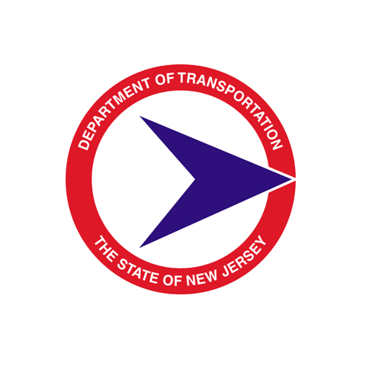
STATE OF NEW JERSEY

DEPARTMENT OF TRANSPORTATION

Quality Management

Design Communications Report

PROJECT NAME:
UPC#:
DESIGNER:
DESIGNER PROJECT MANAGER:
NJDOT PROJECT MANAGER:

Design Activity No. | (Approved date by NJDOT Project Manager) | DCR Entry No.  (use consecutive numbering as issues are submitted for approval)  ____________________________  Survey / Mapping
Who (NJDOT Project Manager/ SME /Stakeholder /Designer)
Design Element issue
Decision and reasoning

Design Activity No. | (Approved date by NJDOT Project Manager) | DCR Entry No.  _____________________________  Geometrics
Who (NJDOT Project Manager/ SME /Stakeholder /Designer)
Design Element issue
Decision and reasoning

Design Activity No. | (Approved date by NJDOT Project Manager) | DCR Entry No.  ____________________________  Hydraulics & Hydrology
Who (NJDOT Project Manager/ SME /Stakeholder /Designer)
Design Element issue
Decision and reasoning

Design Activity No. | (Approved date by NJDOT Project Manager) | DCR Entry No.  ______________________________  Pavement
Who (NJDOT Project Manager/ SME /Stakeholder /Designer)
Design Element issue
Decision and reasoning

Design Activity No. | (Approved date by NJDOT Project Manager) | DCR Entry No.  ______________________________  Geotechnical
Who (NJDOT Project Manager/ SME /Stakeholder /Designer)
Design Element issue
Decision and reasoning

Design Activity No. | (Approved date by NJDOT Project Manager) | DCR Entry No.  _____________________________  Environmental
Who (NJDOT Project Manager/ SME /Stakeholder /Designer)
Design Element issue
Decision and reasoning

Design Activity No. | (Approved date by NJDOT Project Manager) | DCR Entry No.  ______________________________  Utilities
Who (NJDOT Project Manager/ SME /Stakeholder /Designer)
Design Element issue
Decision and reasoning

Design Activity No. | (Approved date by NJDOT Project Manager) | DCR Entry No.  ______________________________  Structures
Who (NJDOT Project Manager/ SME /Stakeholder /Designer)
Design Element issue
Decision and reasoning

Design Activity No. | (Approved date by DPD Lead Engr. or DPM PM) | DCR Entry No.  ______________________________  Right of Way
Who (NJDOT Project Manager/ SME /Stakeholder /Designer)
Design Element issue
Decision and reasoning

Design Activity No. | (Approved date by NJDOT Project Manager) | DCR Entry No.  ______________________________  Access
Who (NJDOT Project Manager/ SME /Stakeholder /Designer)
Design Element issue
Decision and reasoning

Design Activity No. | (Approved date by NJDOT Project Manager) | DCR Entry No.  ______________________________  Landscape
Who (NJDOT Project Manager/ SME /Stakeholder /Designer)
Design Element issue
Decision and reasoning

Design Activity No. | (Approved date by NJDOT Project Manager) | DCR Entry No.  ______________________________  Traffic Engineering
Who (NJDOT Project Manager/ SME /Stakeholder /Designer)
Design Element issue
Decision and reasoning

Design Activity No. | (Approved date by NJDOT Project Manager) | DCR Entry No.  ______________________________  Electrical
Who (NJDOT Project Manager/ SME /Stakeholder /Designer)
Design Element issue
Decision and reasoning

Design Activity No. | (Approved date by NJDOT Project Manager) | DCR Entry No.  ______________________________  Safety
Who (NJDOT Project Manager/ SME /Stakeholder /Designer)
Design Element issue
Decision and reasoning

Design Activity No. | (Approved date by NJDOT Project Manager) | DCR Entry No.  ______________________________  ITS
Who (NJDOT Project Manager/ SME /Stakeholder /Designer)
Design Element issue
Decision and reasoning

