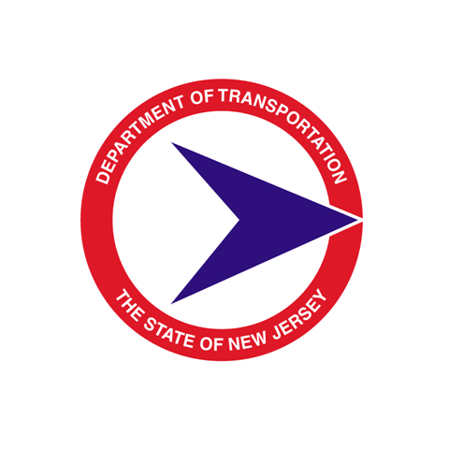
STATE OF NEW JERSEY

DEPARTMENT OF TRANSPORTATION

Quality Management Process

NJDOT In-House Design Quality Management Certification

Final Design Submission

PROJECT NAME: UPC#:

IN-HOUSE DESIGN TEAM LEADER:

DPM PROJECT MANAGER: DPM EXECUTIVE REGIONAL MANAGER:

In accordance with the current Department Quality Management Process and Procedures, in the Designer's professional opinion, and to the best of the Designer's knowledge, information and belief and based upon the performance of the Designer's duties, the Designer represents that the above project has been designed in accordance with all applicable State and Federal design standards and requirements in accordance with the Final Design Scope Statement. Comments and decisions made during Interactive Communications with the Department on design elements and features of the project have been incorporated or satisfactorily resolved and the Contract Documents have been revised accordingly.

__________________________________ ________________________________
In-House Design Team Leader / Date Director, In-House Design / Date
(Bridge or Highway Lead) (Bridge or Highway Lead)

__________________________________
Accepted by DPM Project Manager / Date

